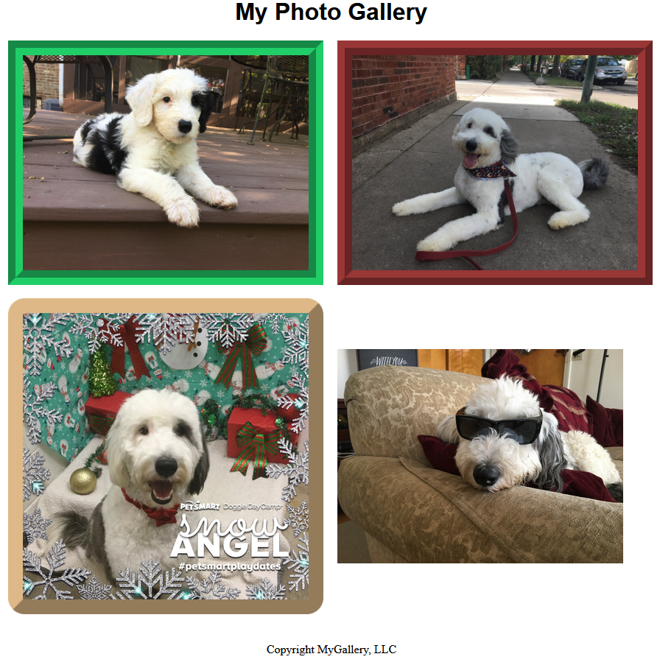

**Size:**

Content area should leave a total 25% of the page empty on either side.

**Copyright:**

Font: Your choice

Size: 12px to 18px

**Title:**

Font: Your choice

Size: 32px to 40px

Type: Bold

**Border:**

Type = 3D*

Color = #993636

Width = 20px

*Notice that this border’s 3D effect is similar to the one on the right, but not identical.

**Gap:**

Separate picture with a space of 15 pixels.

**Title Position:**

Position title 24 pixels below the top of the page.

**Title:**

Font: Your choice

Size: 32px to 40px

Type: Bold

**Border:**

Type = 3D

Color = #993636

Width = 20px

**Image Position:**

This image should be centered horizontally along flex-box cross axis.

**Border:**

Type = 3D

Width = 20px

Radius = 5%

Color = #deb887